**TASK 01:**

Write a sample program to calculate the average of 5 subjects..

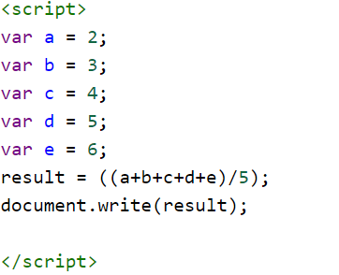

**TASK 02:**

Write a program toimplement a decision making statement.

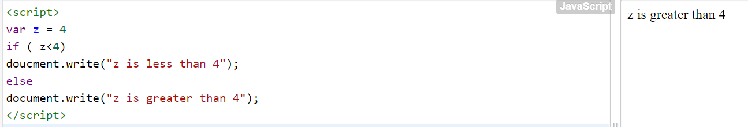

**TASK 03:**

Write a program to ask users to enter the number in the range of 1-20 and see if the number is sorted or not. If not write a program to sort them. Also can enter maximum 5 values.

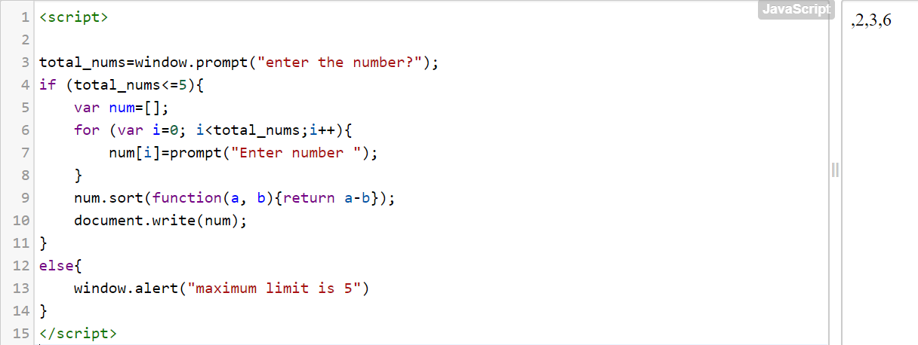

**TASK 04:**

Upload the code file on GitHub with a new repository.